Physics Stage 3: Particles, Waves and Quanta 2010

Test Two
Name: _____________________________________________________________ (48 marks)
- Absorption and emission spectra of gases in the atmosphere are line spectra rather than a broadband or continuous spectra. Explain why. (3 marks)

________________________________________________________________________________________________________________________________________________________________________________________________________________________________________________________________________________________________________________________________________________________________________________________________________________________________________________________________________________________________________________________________________________________________________________________________________________________
- Some minerals will show colours under ultra-violet light. What is the name of this phenomena and how does it occur? Include a diagram with your answer. (4 marks)

________________________________________________________________________________________________________________________________________________________________________________________________________________________________________________________________________________________________________________________________________________________________________________________________________________________________________________________________________________________________________________________________________________________________________________________________________________________
_____________________________________________________________________________________________________________________________________________________________________________________________________________________________________________________________________________________________________________________________________________________________________________________________________________________________________________________________________________________________________________________________________________
- X-rays can be produced using a device similar to the one represented below. The labels on the diagram at A, B, C and D are missing. Write in the missing labels. (2 marks)
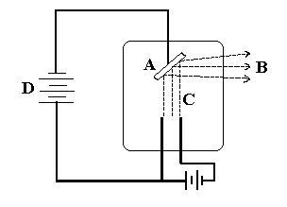
A: _______________________________

B: _______________________________

C: _______________________________

D: _______________________________
- a. Consider the following statement. “The distances to different galaxies is proportional to red-shift of that galaxy with the more the red-shift, the further away the galaxy.” This
statement is know as _____________________________________________ (1 mark)

- How does “red-shift” support the Big Bang Theory? (4 marks)
________________________________________________________________________________________________________________________________________________________________________________________________________________________________________________________________________________________________________________________________________________________________________________________________________________________________________________________________________________________________________________________________________________________________________________________________________________________________________________________________________________________________________________________________________________________________________________________________________________________
- The Big Bang theory predicts that the universe is expanding. Name and describe two possible futures for our expanding universe. (2 marks)

________________________________________________________________________________________________________________________________________________________________________________________________________________________________________________________________________________________________________________________________________________________________________________________________________________________________________________________________________________________________________________________________________________________________________________________________________________________
_________________________________________________________________________________________________________________________________________________________________________________________________________________________________

- Muons form when cosmic radiation hits air molecules high up in the Earth’s atmosphere. The average life expectancy of a muon before it decays is about 2.2 x 10⁻⁶ s and it can travel about 0.999 c (99.9 % the speed of light). Determine the distance a muon could travel within its lifetime. (2 marks)

- Consider the following example which helps to explain Einstein’s special relativity. Observer A is standing in the middle of a train which is travelling very fast. He presses a button which opens the front and back doors of the train at the same time. Observer B is standing on a platform watching the train go by. The diagram below shows this situation.

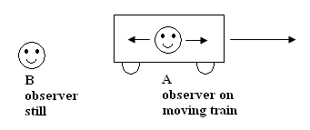

  - What does observer A see? _________________________________________________
________________________________________________________________ (1 mark)
  - What does observer B see? _________________________________________________
_________________________________________________________________ (1 mark)
  - Who is right, A or B? Explain your answer. (2 marks)
________________________________________________________________________ ________________________________________________________________________ ________________________________________________________________________ ________________________________________________________________________
- Strong nuclear forces hold protons and neutrons together. Protons and neutrons are hadrons and each hadron is made up of three quarks. There are six types of quarks each of which has a fractional charge. Up-type quarks have a charge of +2/3 electric charge, while down-type quarks have -1/3 electric charge. If an electric charge is the charge on an electron, determine the quarks that make up a neutron and a proton. You must show your working to justify your answer.

- a neutron (2 marks)

- a proton (2 marks)

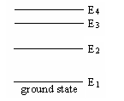
- A certain gas is composed of excited atoms. The diagram illustrates the energy levels available to the electrons (not including ionization level). How many lines would be in the full emission spectrum?

______________________________________ (1 mark)
Show in the diagram the transitions that give rise to these lines.
(1 mark)
- Fluorescent tubes contain low pressure mercury vapour whose atoms are excited by electrons travelling between the ends of the tube. Some of the energy levels of a mercury atom are shown to the right.
  - Determine the wavelength of photons produced when ground state electrons are excited to level E₄ and return to level E₁. (3 marks)
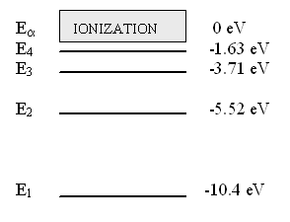

- To what region of the electromagnetic spectrum do these photons belong? (1 mark)
________________________________________________________________________
- The term “ground state”, “excited state” and “photons” are used in part (a). What do each of these terms mean? (3 marks)
________________________________________________________________________ ________________________________________________________________________ ________________________________________________________________________
________________________________________________________________________ ________________________________________________________________________ ________________________________________________________________________
________________________________________________________________________ ________________________________________________________________________
________________________________________________________________________ ________________________________________________________________________
________________________________________________________________________ ________________________________________________________________________
________________________________________________________________________ ________________________________________________________________________
- Ultra-violet Astronomy investigates energetic processes in stars and galaxies. This is because ultra-violet radiation has shorter wavelengths and more energy than visual radiation. An ultra-violet telescope is set up on a satellite to photograph an evolving galaxy.

  - Can an Ultra-violet telescope be set up on the ground? Explain. (1 mark)
_________________________________________________________________________________________________________________________________________________________________________________________________________________________________________________________________________________________________________________________________________________________________________________________________________________________________________________________________________________________________________________
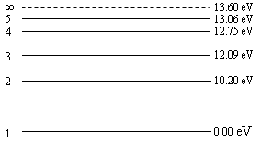
  - If the satellite records radiation with a wavelength of 9.75 x 10⁻⁸ m, between what two energy levels must the electron jump to produce this line? (3 marks)

  - An electron is given 13.61 eV. What does this mean for the electron and what name do we give this process? (2 marks)
__________________________________________________________________________________________________________________________________________________________________________________________________________________________________________________________________________________________________________________________________________________________________________________________________________________________________________
- a. A SHARP Carousel Microwave Oven model R480L has the following specifications:
- Output power = 1100 W
- Microwave frequency = 2450 MHz
- Depth with the open door = 860 mm
- Outside dimensions (WxHxD) = 550mm x 315mm x 446mm
- Cooking Uniformity = Turntable (φ320mm tray) system
The specification book for the microwave oven states that standing waves are set up in the oven. Show by calculation whether the specification book is correct or not. (3 marks)

  - The magnetron which produces the microwaves in the oven causes photons to be emitted. How many photons are emitted each second by the magnetron? (2 marks)

